LY display 810manual

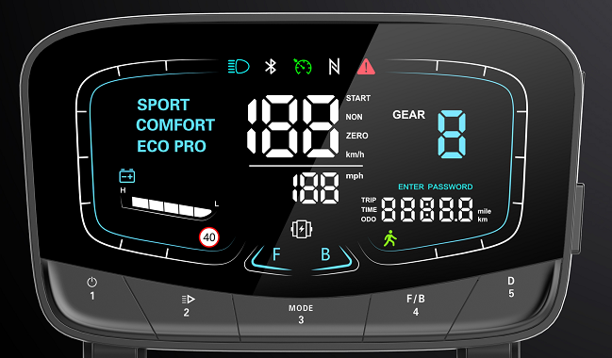

The fault status displays the area E, when the symbol is flashing, press the M/3 key to adjust the display interface to the E interface, the corresponding number under the interface represents the corresponding fault content, the specific status is as follows

E-001 电机霍尔故障 E-001 Motor Hall fault

E-002 转把故障 E-002 Handle failure

E-003 控制器故障 E-003 Controller failure

E-004 刹车故障 E-004 Brake failure

E-005 电压故障 E-005 voltage fault

E-006 通讯故障（仪表收不到控制器信号）

E-006 Communication Failure (Instrument Does Not Receive Controller Signal)

E-007 通讯故障（控制器收不到仪表信号）

E-007 Communication Failure (Controller Does Not Receive Instrument Signal)

**Wiring mode:**

1. Red wire (D +): Positive input of power supply
2. Black wire (GND): Negative pole of power supply
3. Blue wire (DS): Controller switch lock
4. Green line (Tx): Communication transmission
5. Yellow line (RX): Communication reception
6. Grenade Hall Signal Station

Special note: The meter has Bluetooth, and has NFC function and password boot IMG_256This icon represents the NFC function)There are three options for P95 in the background of the instrument: 0 means no password and NFC swipe card to boot up, 1 means that only the NFC card can be used to boot the computer, and 2 means that the password and NFC swipe card can be turned on.The specific use is as follows:

1. When the background is set to 0, you only need to press the boot button briefly to boot and use
2. When the background is set to 1, a letter N will appear above the instrument by pressing the power on button, which means that you want to swipe NFC to open the machine to turn on the phone, pay attention to the NFC card has a special card area, the meter has the word printed NFC, swipe the card in this area to boot the machine.

3. When the background is set to 2, N will appear on the meter by pressing the power on button and **1f8997f9d29e2fd01640320c82d8c0a.If you want to use NFC to boot the same as the operation steps of item 2, if you choose the password to boot (when the instrument P96 is set to 2 the default password is 1234), directly enter the password 1234 (when choosing the password to boot, the first digit needs to long press the number after more than 1 second short press can be) according to the number button on the meter corresponding to the number can be turned on, here to remember that whether it is to boot with a password or NFC card to boot must complete the boot action within 5 seconds of short press the boot button, otherwise the instrument will automatically sleep, You need to press the power on button again to wake up the meter.**

4.

Bluetooth contact , downlaod APP 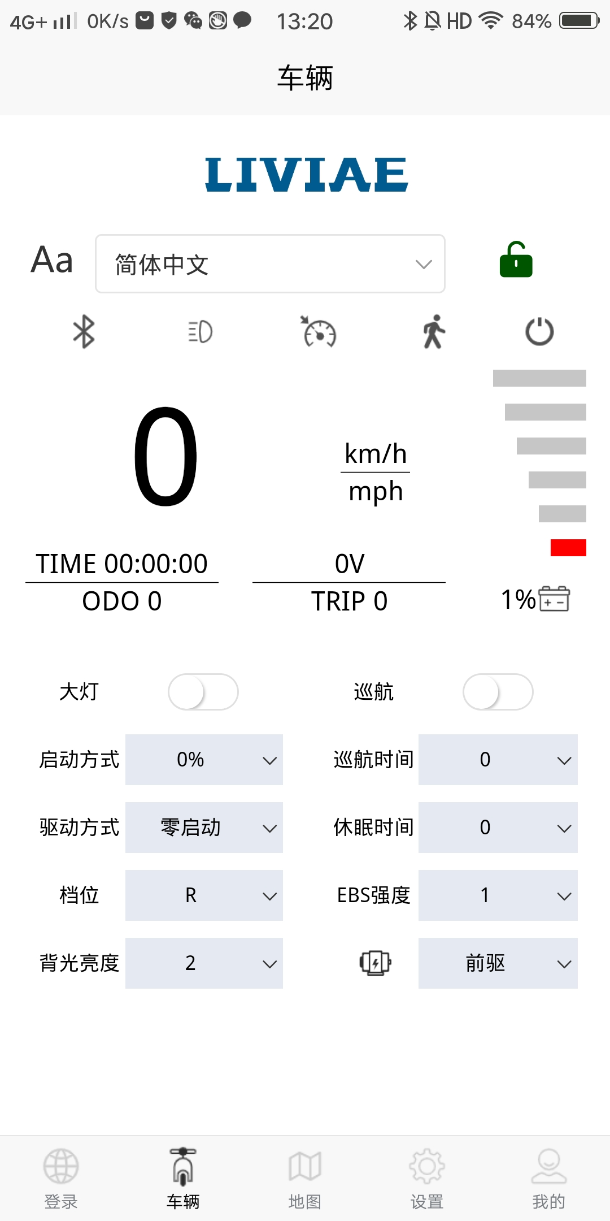

Android users scan QR code 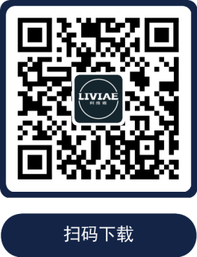and download. IPhone users directly search in the Iphone store

Open APP Will shows Click the Bluetooth icon to search for the Bluetooth name connection with the beginning of LIVIAE, and click the Bluetooth icon to jump to the login interface

数：，需要注册绑定才能修改参数，防止他人误操作导致车辆异常。

If you don't want to register the binding, you can directly log in with the shortcut.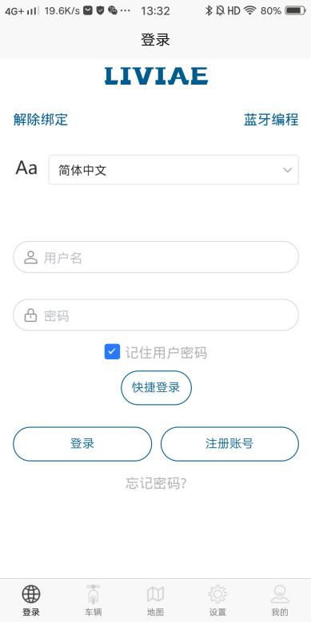Quick login cannot enter the instrument background to modify parameters: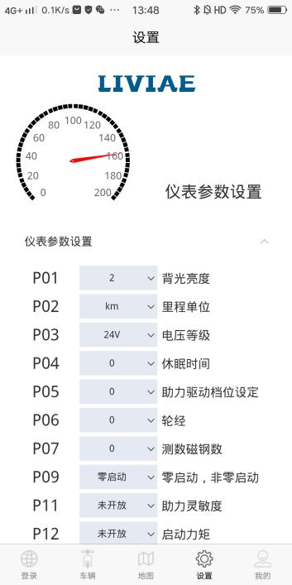You need to register the binding to modify the parameters and prevent the vehicle from being abnormalized by misoperation.

How to register

1. lick Register Account and enter the information according to the interface.

2. After the information is registered, it will jump to the login interface and click Login.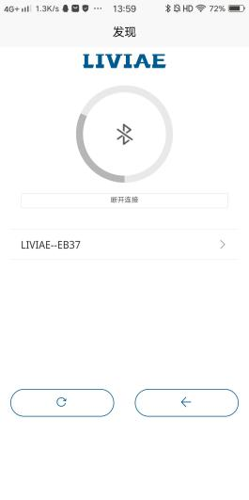

3.There will be this search Bluetooth interface, click on the name with LIVIAE at the beginning of the click, scan the code box, at this time directly scan the code or enter the barcode number and letter can be bound to enter the vehicle interface, the barcode is generally in the manual or the side of the instrument or the back of the instrument.

About NFC

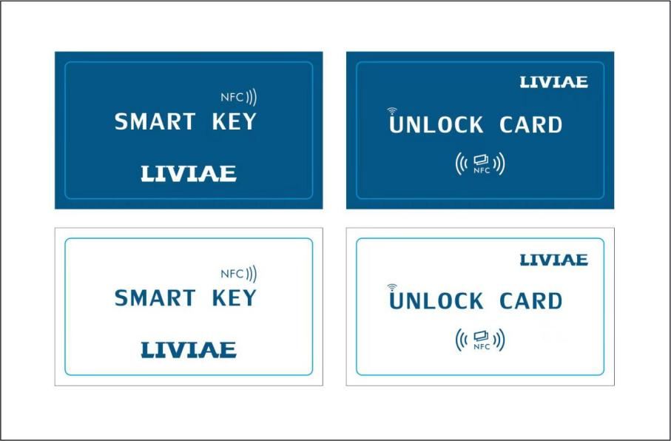

1. Generally, there are 3 cards left the factory, and the blue one is the main card. The white one is the secondary card.

2. Blue main card: equivalent to the key is generally placed at home without a body, the main card can not play the role of booting, such as the white sub-card lost and you want to match the key is with a white sub-card, at this time you need a blue main card to match this key, equivalent to the blue main card is the master, the white sub-card for the guest, the guest wants to enter the door need the owner's consent.

3.Here explains how to use the blue main card, the premise P96 must be set to 1 or 2, short press the boot button (within 5 seconds) to swipe the blue main card in the NFC card area, at this time the number 1 will appear on the meter, when 1 appears to swipe the first white card, appear 2 to swipe the second card, when there is 3 you do not have the third white card casually in the swipe of a white card is completed, at this time the instrument will automatically shut down, each time the card will have a drop. Press the power on button to swipe the white card to turn on.

1. Short press the No. 1 button to turn it on, and long press the No. 1 button to shut down.

**Press button 3 and button 5 at the same time to enter the background function layout:**

P01: Backlight brightness, 1-10

P02: Mileage unit, 0:km 1:mile, 2:km mile full display

P03: Voltage level, 24V 36V 48V 52V 60V 72V

P04: sleep time, 0: no sleep Other numbers are sleep time, range: 1-60; Units in minutes

P06: Wheel: unit, inch; Accuracy: 0.1

P07: Measuring the number of magnets; Range: 1-100

P09: Zero start, non-zero boot setting, 0: zero start; 1: Non-zero boot

P10: Drive mode setting 0 assist drive; 1 Electric drive; 2 Power drive Electric drives coexist

P11: Assist sensitivity setting 1-24

P12: Starting torque: range: 0-5, 0 weakest, 5 strongest

P13: Booster plate magnet type setting 5. 8. 12

P15: Motor drive signal percentage setting is set to 100% full speed

P16: Instrument real-time cruise function: 0: No function 1: There is this function

P19: Taillight setting, 0: Taillight is always on 1: Taillight is synchronized with headlights

P20: Boot Settings: 0: Soft Boot 1: Normal Boot (50%) 2: Hard Boot (100%)

P21: Electronic brake strength: 0: none, 1 Yes (class 1-10)

P92: Handle Hall setting: 0; No rotary handlebar function, 1: There is a rotary handle function

P93: Change password: Press the number 3 button to change the password

P95: Boot mode: 0: No password / No NFC 1: There is NFC (Note: You can only boot with NFC. Pressing the boot button has no effect), 2: There is a password (4-digit password default 1234) / NFC

P96: Speed limit 40km setting: 0; The speed limit of 40km can not be canceled directly, 1; long press No. 3 to enter the speed limit of 40km/h can lift the speed limit of 40km, 2: long press the No. 3 button can enter the speed limit of 40km/h can not be lifted, need to shut down in the boot to lift.

P97: Drive icon setting: 0 No this function (can not switch single and dual drives), 1: With this function (can switch single and dual drives); 2: The default is dual drive

P98: One-click start: 0: No this feature, 1 has this featureP99: One-key recovery (under the P99 parameter setting interface, long press the number 3 key for 5-6 seconds, all parameters are restored to the initial parameters of the instrument)

ODO: odo zero clearing (under the ODO parameter interface, first briefly press the No. 3 button, and press and hold the No. 3 button for 5-6 seconds until the digital clearance is released)

1. **Operation Instructions**

**1666846056414Press and hold the No. 2 button to turn on the headlights/long press to turn off the headlights at the same time as the headlight icon62306a78b2636bf3ecb9934e72ae319Follow the button to light up or turn off synchronously, and press the number 2 key to switch the start mode.Long press button 3ad76b8173b3803b56e65fb933cbcf3eEnter the speed limit and light up the speed limit icona5244e933ee8591b3eed8e065d3e554,Short press button 3ad76b8173b3803b56e65fb933cbcf3eODO/TRIP/TIME/fault code E/voltage V can be flipped49a7d0c77048565ed8e33837c877454Long press button 5cdbfca03e387950dafcb35e192eddd0Light up the 6km humanoid icon4f7b6f415ad3634616492cb9f19c81bAnd turn on this function, and long press the No. 5 button againcdbfca03e387950dafcb35e192eddd0You can cancel the pedestrian icon and return to the current gear. NO.4buttom df503bb78f190594a99c73e0e633fda is single /dual motor mode .Short press the No. 4 button to switch various drive modes, such as the front-drive work icon5b44e42c4c83e6a3421c4df4c30f555Rear drive working icon a4a89a3386745b7de5587fcbf43e102 dual tron motors working icon a0300acf1a246fa3add3ace2cd9e975.Short press button 5cdbfca03e387950dafcb35e192eddd0is the gear, this button also works in a cycle, and the current maximum is 3 gears.Press button 3 ad76b8173b3803b56e65fb933cbcf3eand button 5 cdbfca03e387950dafcb35e192eddd0at the same time**

**to enter the background (after entering the background, you need to press the No. 3 button shortly, when the number is flashing, you can modify the parameters through the No. 4 button and the No. 5 button. Short press the No. 4 buttondf503bb78f190594a99c73e0e633fdaReduce 1,Short press button 5cdbfca03e387950dafcb35e192eddd0can add 10.After adjusting the parameters you want, you need to long press the No. 3 buttonad76b8173b3803b56e65fb933cbcf3eUntil the number does not flash, the setting is successful).After entering the background, when there is no modification of the parameters, the No. 4 button and the No. 5 button can be switched, P01-ODO can be used as the up-down button, and after the parameter adjustment, press No. 3 and No. 5 at the same time to return to the home page.**

**三． Set passport**

**First of all, the factory with the default password (1234), elaborate: how to set the password into the background to select P95, here is an example to illustrate the choice 2, when we P95 choose 2 when the P93 function is turned on, and will produce an initial password 1234, let's talk about changing the password, when the password is set successfully want to change the password, adjust the parameters to P93 to see the factory password 1234, short press the No. 3 button, this time the main interface icon1f8997f9d29e2fd01640320c82d8c0aStart to light up and stay on, icon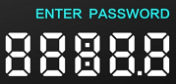The number began to flash 4 horizontal bars, at this time enter the 4-digit password you want to decide, short press the number 3 button number number does not flash the icon1f8997f9d29e2fd01640320c82d8c0aIt means that the password has been set successfully, and so on if it needs to be changed again. When the P95 selects with password/NFC, every time the instrument is restarted, press the No. 1 button, and only this icon will appear on the main interface of the boot screen1f8997f9d29e2fd01640320c82d8c0aAnd the number becomes 4 horizontal bars, and the user needs to enter the correct password to restore the main interface (you need to press and hold when entering the first number, and the subsequent numbers do not need to) or directly use the NFC card to swipe the machine, the two coexist, which one is used first.**

1. **How to turn on**

**This is the icon that represents each different start mode, the factory default is ECO PRO for soft start energy-saving mode, you can set the default boot mode through the background, enter the background to select P20 to adjust 0 on behalf of ECO PRO, 1 represents COMFORT, 2 represents SPORT, during the driving process can be short press the No. 2 button to switch various starting methods respectively, No. 2 key is cyclic work, background P20 as the default boot choice.**

1. **The specified time of short press of the key is 0.3 seconds, and the specified time of the long press of the key is 2 seconds.**

Note: Due to the upgrade of the company's products.The display information of the products you get may be different from the manual.It will not affect your normal use.

**ADD: No. 3, Qingyun Road, Niutang Town, Wujin District, Changzhou City, Jiangsu Province**